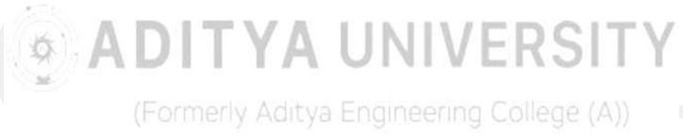
WEEK-8
AIM: Add animations to UI elements using Flutter's animation framework

DESCRIPTION: In this tinkering activity, animations are added to UI elements using Flutter’s built-in animation framework to make the interface more dynamic and engaging. Widgets like AnimatedContainer, AnimatedOpacity, or AnimationController are used to create smooth transitions, motion effects, and interactive visuals. This helps learners understand the basics of implicit and explicit animations, improving the user experience and visual appeal of Flutter applications.

PROGRAM:
import 'package:flutter/material.dart';
void main() => runApp(MaterialApp(home: SimpleAnimation())); class SimpleAnimation extends StatefulWidget {
const SimpleAnimation({super.key});

@override
State<SimpleAnimation> createState() => _SimpleAnimationState();
}

class _SimpleAnimationState extends State<SimpleAnimation> { bool big = false;
@override
Widget build(BuildContext context) { return Scaffold(
body: Center(
child: AnimatedContainer( width: big ? 200:100, height: big ? 200:100,
color: big ? Colors.orange:Colors.blue, duration: const Duration(seconds: 1),
),
),
floatingActionButton: FloatingActionButton(onPressed: () => setState(() => big = !big), child: const Icon(Icons.play_arrow),),
);
}
}

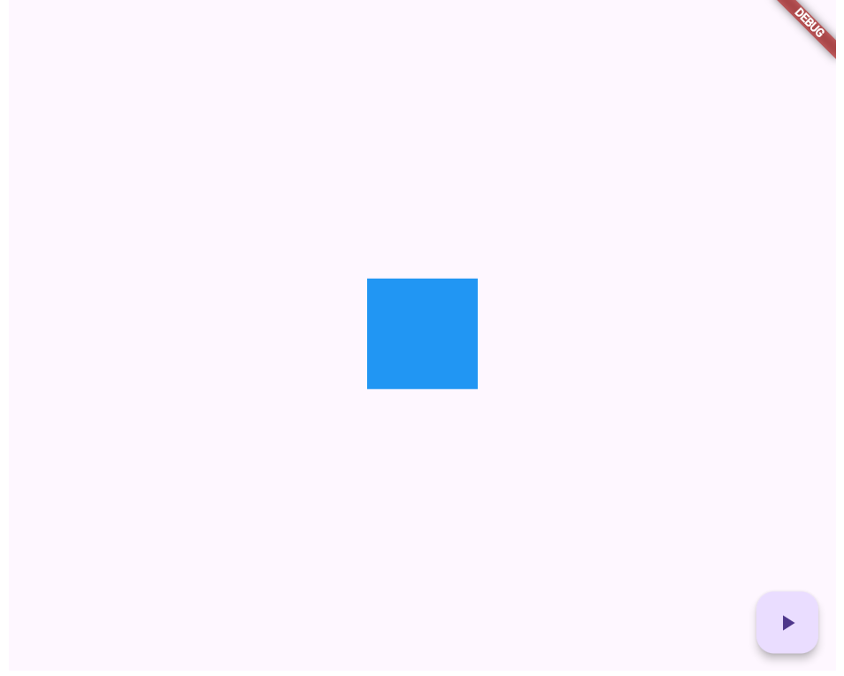
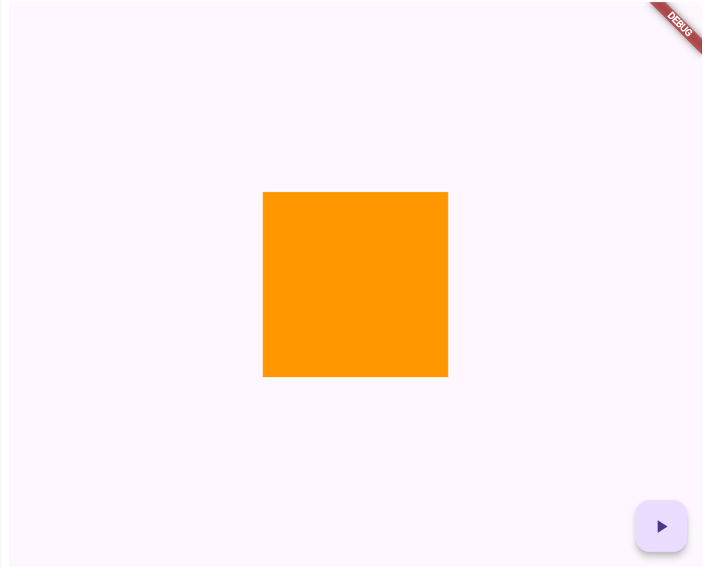
OUTPUT:

B) AIM: Experiment with different types of animations (fade, slide, etc.).

DESCRIPTION: In this tinkering activity, different types of animations such as fade, slide, scale, and rotation are implemented using Flutter’s animation widgets. The experiment demonstrates how motion can enhance user interaction and make UI transitions smoother. By adjusting animation duration, curves, and effects, learners explore how various animations influence the overall look, feel, and responsiveness of an app’s interface.

PROGRAM:
import 'package:flutter/material.dart';
void main() => runApp(const MaterialApp(home: SimpleAnimation())); class SimpleAnimation extends StatefulWidget {
const SimpleAnimation({super.key});

@override
State<SimpleAnimation> createState() => _SimpleAnimationState();
}

class _SimpleAnimationState extends State<SimpleAnimation> { bool big = false; // using this instead of 'on'

// Helper widget for reusable boxes
Widget _box(Color color) => Container(width: 80, height: 80, color: color);

@override
Widget build(BuildContext context) { return Scaffold(
appBar: AppBar(title: const Text("Simple Animation Example")), body: Center(
child: Column(
mainAxisAlignment: MainAxisAlignment.center, children: [
// Fade animation AnimatedOpacity( opacity: big ? 1 : 0,
duration: const Duration(seconds: 1), child: _box(Colors.blue),
),

const SizedBox(height: 20),

// Slide animation AnimatedSlide(
offset: big ? Offset.zero : const Offset(-1, 0), duration: const Duration(seconds: 1),
child: _box(Colors.green),
),

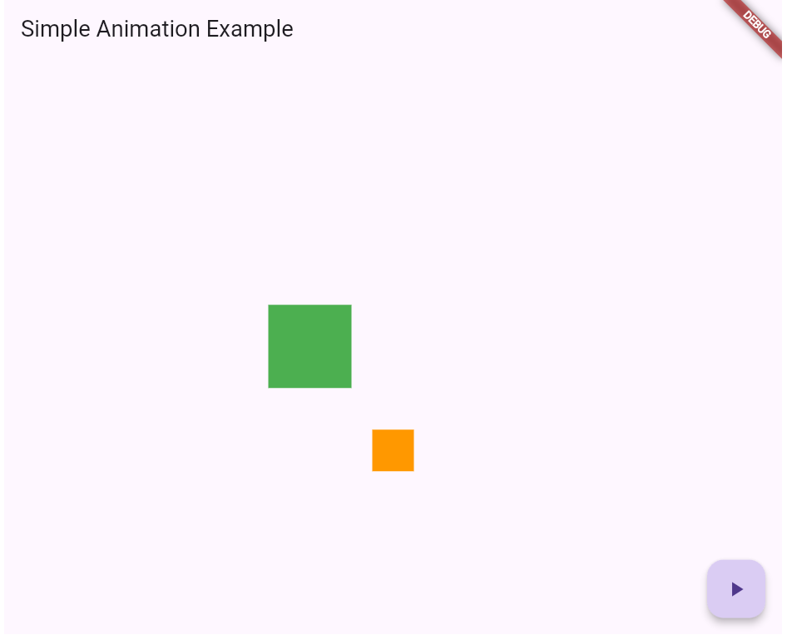
const SizedBox(height: 20),

// Scale animation AnimatedScale( scale: big ? 1 : 0.5,
duration: const Duration(seconds: 1), child: _box(Colors.orange),
),
],
),
),
floatingActionButton: FloatingActionButton( onPressed: () => setState(() => big = !big), child: const Icon(Icons.play_arrow),
),
);
}
}

OUTPUT:

